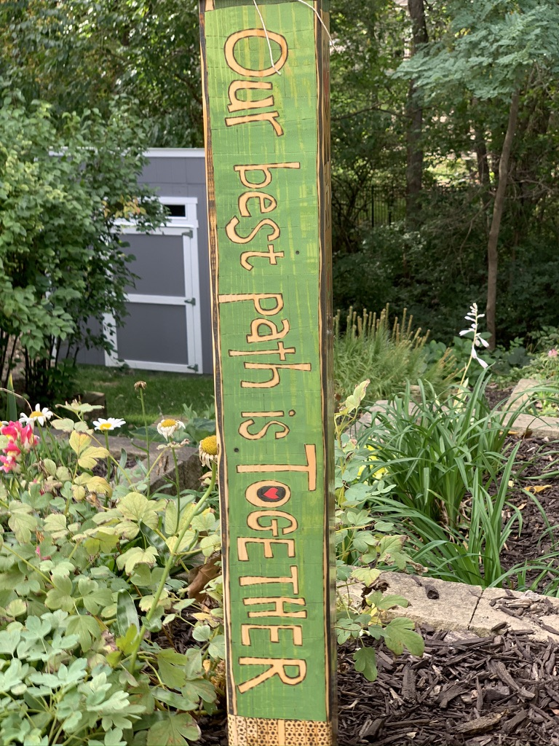
Whoever wishes to become great among you must be your servant, and whoever wishes to be first among you must be slave of all. For the Son of God came not to be served but to serve, and to give his life a ransom for many. Mark 10:41-45

One year ago, the Stewardship team gathered to formulate plans for our annual Every Member Canvass campaign. We took the opportunity to highlight our many accomplishments that had occurred in 2020 despite the pandemic.

“Our Best Path is Together” theme drew its inspiration from a peace pole, reflecting our belief that together, as a community, we will continue to answer God’s call to be faithful, have compassion, and be courageous. Our community is our strength, providing us with connection, the love of belonging, and the grace of pure joy.

2021 has posed many unique opportunities to live into this call. The pandemic has …. just about faded, almost, if you pull up your mask and squint just right. We have been asked to serve our faith community in ways that many of us would not have imagined a year ago.

The support of our team-based ministry structure has become the energy that has kept our lights on, our outreach programs thriving, and our Sunday worship flourishing. Team highlights include:

- The Community Team has expanded Simply Essentials to include our neighborhood schools, Monroe and Hillis Elementary, and Hoover High School.
- The Education Team is hosting “The 1619 Project” examining the impacts of racism across all aspects of our community.
- The Gathering Team is finding new ways to foster connections among everyone, drive-in theater at Valley West Mall, youth soccer games, and movies in the park.
- The Property Team completed a water mitigation project and has contracted for new windows in the Gathering Room.
- The Stewardship Team has worked on documenting and revising our management systems and procedures.
- The Worship Team hired a new music director and has continued Zoom and outdoor services.

We have shown time and again that in fact “Our Best Path is Together”. Where then is our path for 2022?

The decision concerning clergy leadership is going to be discussed and decided by our entire community at the Annual Parish Meeting held at the end of January 2022. At this time, we will have worked within a Team Based Ministry model for approximately six months and will be in a good position to determine our path forward.

Our Every Member Canvass is an opportunity to meet the call to be faithful, compassionate, and courageous servants of God. It will take resources to support our outreach programs, to provide engaging worship, and maintain our building and grounds.

We ask that you prayerfully consider making your pledge to St. Andrew’s for 2022.

If this is your first experience with pledging, please evaluate the resources you have been given and consider what you are able to return to God’s work.

If you have previously pledged, thank you! Please consider an increase of 3% or more for 2022.

Your commitment to sharing of your time, talent, and treasure is more important than ever.

mailto:busmgr.standrew@gmail.com?subject=My Pledge for 2022

In Faith,
Kathie Danielson Leanne Williams
Senior Warden Junior Warden

Vestry Members:

Deb Brewer-Cotlar
Jim Carpenter
Carrie DeVries
Myra Knapp
Kinsey Mazunik
John Sellers
Mattie Spain

